Rectified Gaussian distribution

Def

From Wiki,

Rectified Gaussian distribution is a modification of the [Gaussian distribution](https://en.wikipedia.org/wiki/Gaussian_distribution) when its negative elements are reset to 0 (analogous to an electronic [rectifier](https://en.wikipedia.org/wiki/Rectifier)). It is essentially a mixture of a [discrete distribution](https://en.wikipedia.org/wiki/Discrete_distribution) (constant 0) and a [continuous distribution.](https://en.wikipedia.org/wiki/Continuous_distribution)

PDF

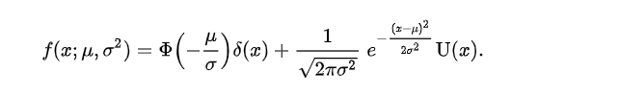

CDF

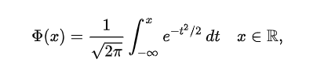

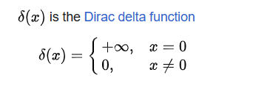

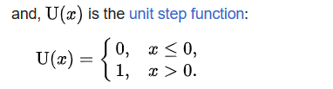

Expected Value



Variance



Generating Values

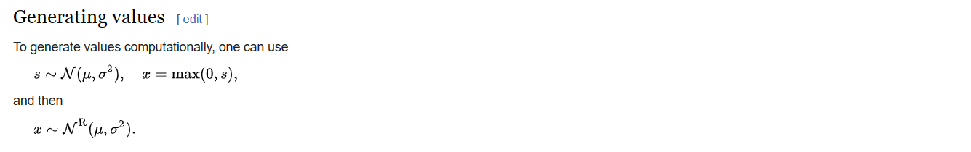

## Extension to general bounds

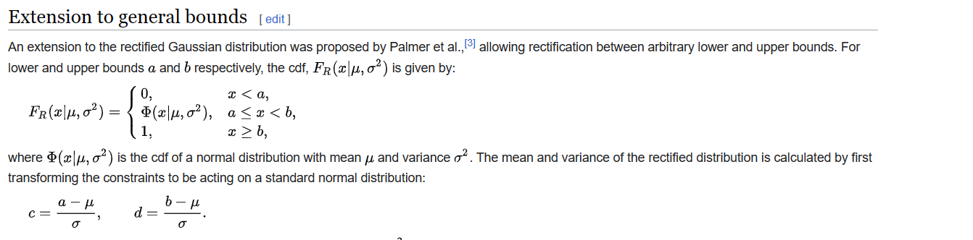

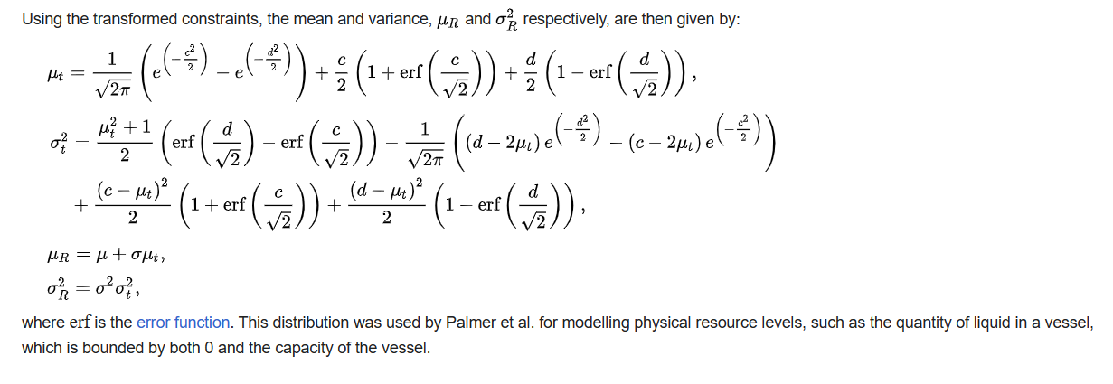

Application

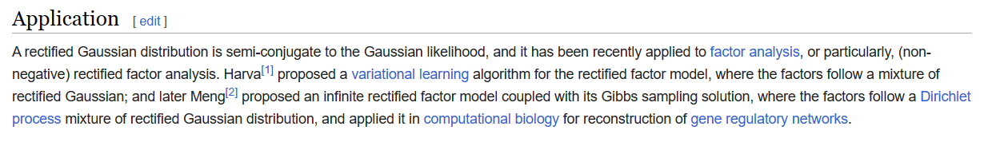

Ref

[Rectified Gaussian distribution - Wikipedia](https://en.wikipedia.org/wiki/Rectified_Gaussian_distribution)